Coordinated Entry Mobility Request Form
Rationale
Coordinated Entry promotes housing stability and recognizes that circumstances arise which may require a change in a current housing placement.
Policy
Households eligible for a Mobility Transfer are prioritized for referral to another housing program. Households are potentially eligible for Mobility Transfer regardless of how they were referred to their current placement: eligibility is not limited to those who were referred via Coordinated Entry prioritization. Current and former residents of housing programs that accept referrals from CE are eligible for mobility transfer.
- If a household exits a CE participating housing program into homelessness within the last 180 days (about 6 months) they remain eligible for a Mobility Request with the support of a provider/navigator. However, the new episode of homelessness may impact housing eligibility, including chronic homelessness status.
- If a household was housed through Rapid Rehousing but has since exited the RRH program (while remaining housed) and are facing imminent risk of homelessness they are eligible for MR with the support of a provider/navigator.

Process: PLEASE NOTE: PROCESS CHANGE AS OF 10/16/23
- The housing provider must send the completed Mobility Request form to the KCRHA Mobility Request email address- mobilityrequest@kcrha.org , documenting the reason for Mobility Request in detail. Mobility Requests must indicate steps taken by housing staff to support the household and seek options that would keep the household housed within their program if possible. In addition, information about the proposed new housing placement that would mitigate or eliminate a reemergence of the previous instability. Once a Mobility Request has been submitted, their Case Manager/Navigator must support the household through the process until they are successfully (re)housed.
- CE staff will follow up within one business day if there is a safety issue, and within three business days otherwise. Additional information may be required, timeliness of correspondence by the party submitting the request can impact processing duration.
- If a Mobility Request is approved, the provider who submitted the MR is responsible for nominating the household to Coordinated Entry resources as outlined in the CE Nomination Job Aid. Nominated households with active approved MRs will be prioritized for referral. Households who have been approved for mobility for safety reasons will be prioritized over non-safety reason mobility requests, followed by households in danger of losing their housing first. Nominations for households with Mobility Request still under review will not be considered for referral.

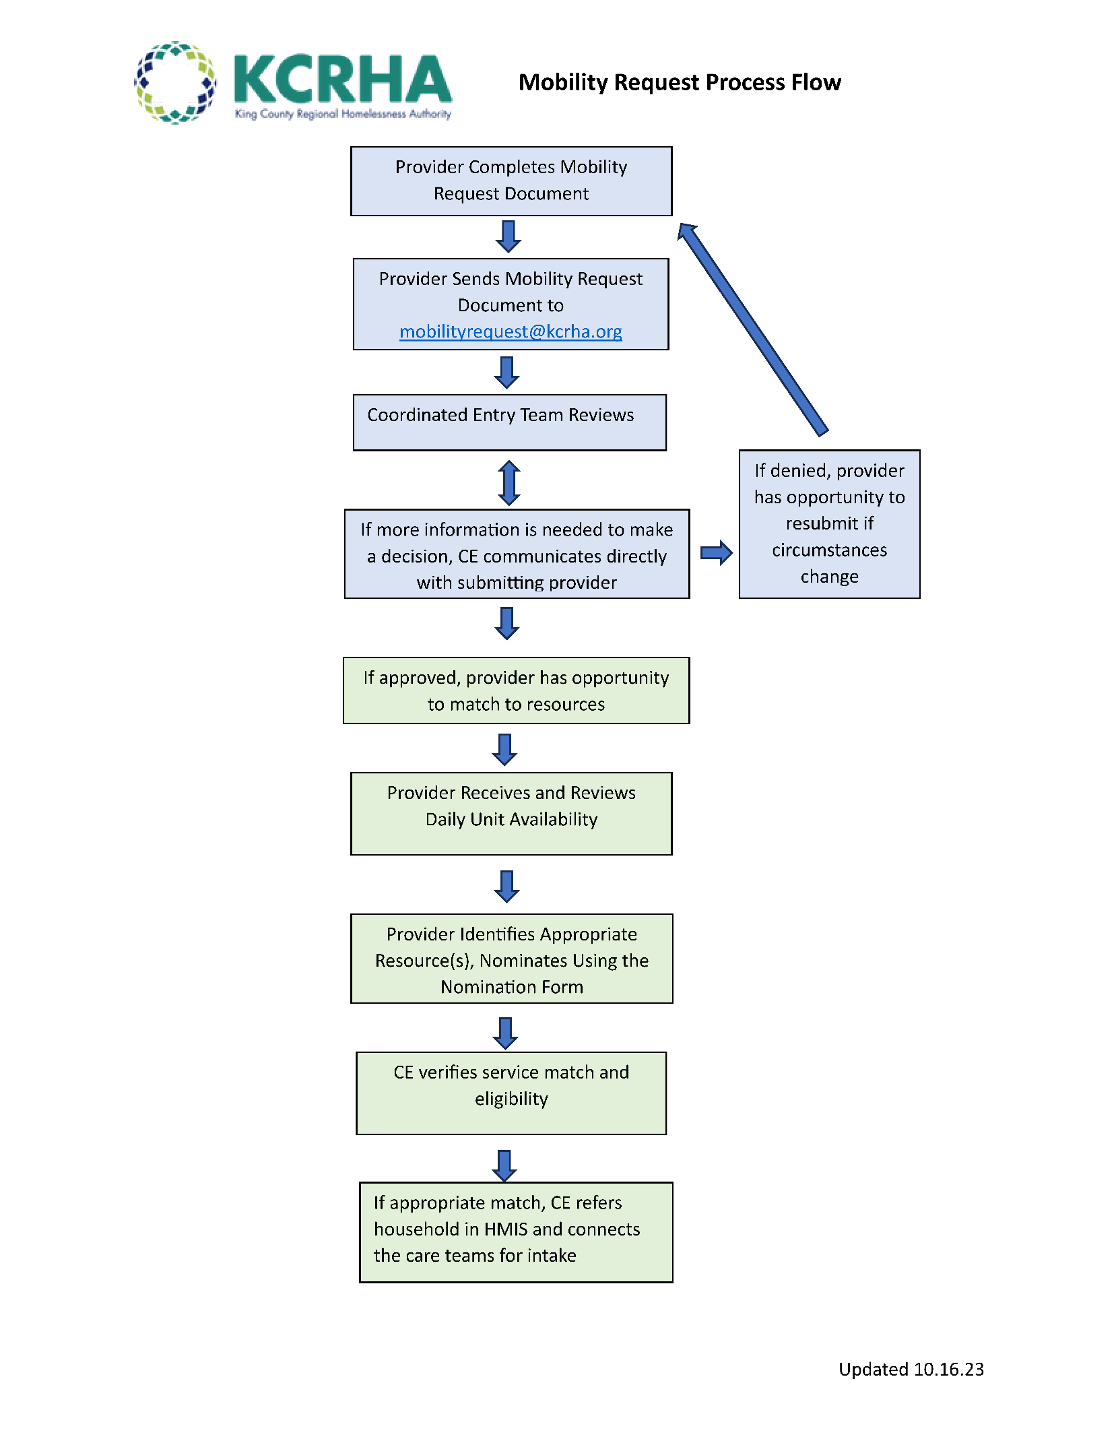

Today’s Date: |  | Initiator of MR: Provider____ Client_____  Are the resident and housing provider in agreement on the change requested?
Name of staff completing form: |  | Staff contact information:
HOH Name: | HMIS Unique ID: | HOH Date of Birth: | Household Size:
For families: please describe household’s current custody of minors:

Current Program Enrollment: |  | If housed through RRH, date of move-in:
Household able to document chronic homelessness?: |  | Household able to document disability?:  Need ADA unit?:

Categories
Imminent Safety Risk: when a household is at risk of violence and needs to be moved to a different location. Mobility Requests under this category will be prioritized. Note that disagreements between neighbors are expected to be mediated by the property first.
Geographic Change: is often used in situations of joint custody, if parents need to be closer to each other in order to be in compliance with their custody agreement.
Change in Service Need: when a program and a household agree that a household is in need of either a decrease or increase in services related to circumstances that have changed since enrollment in the original program. Examples could include a medical event or permanent disability, or a need for more intensive on-site case management support.
Exiting due to Age Restrictions: when a young adult is aging out of their current program with no other housing options. This also applies to youths (under 18) who are aging out of shelter or other homeless services and will be experiencing homelessness upon program exit.
Change in Family Size/Household Type: when a household is anticipating a change in family size resulting in the household being over or under occupancy for their unit. This also applies if a household is moving from one population to another (i.e. from being a single adult household to a family household with minors.)
Office of the Ombuds Pathway: Referral from KCRHA Office of the Ombuds when significant concerns about the current housing placement are raised.

Please Identify the reason(s) for the Mobility Request:
Select all that apply

Imminent Safety Risk ☐ Exit Due to Age Restriction ☐
Geographic Change ☐ Change in Family Size or Household Composition ☐
Change in Service Need ☐

Please complete each section that applies to the reason selected and provide a detailed narrative. The narrative should explain why the request is being submitted and include any interventions attempted to prevent relocation.

Imminent Safety Risk
If the household requires a confidential resource, please note that CE resources are not able to provide this level of security. Please reach out to the CE team if you'd like a connection to DV-specific housing resources.
- Is a move required to assure safety of the resident? Yes ☐ No ☐
- Were safety concerns present at intake? Yes ☐ No ☐
Please explain:
- Please list any unsafe areas for the household:
- Is the resident able to remain in the current program until another resource is identified? Yes ☐ No ☐
If not, what other housing options have been identified?

Narrative:

Geographic Change

- Location or region requested:
- Reason for requested change:

Narrative:

Exiting due to age restrictions

- What is the date the resident must exit the program?

- What other housing solutions has the care team pursued?
- If this is a transitional housing resource, has an extension been pursued with the funder?

Narrative:

Change in Service Need

- Does the resident need an increased or decreased level of support? Increased ☐ Decreased ☐
- Why is the current level of support not meeting the residents’ needs?

- Was the resident’s level of service accurately captured during intake? Yes ☐ No ☐
  - If no, what was inaccurate or omitted?

- What interventions have been attempted to maintain housing stability?

Narrative:

Change in family size or household type

- Is the resident pregnant? If yes, what is their due date? Yes ☐ No Due Date________
- Is the resident reuniting with their child(ren)? Yes ☐ No ☐
  - Number of adults in the household:
  - Number of children in the household:
Narrative:

Mobility Request Review Decision Rubric
Category | Factors Present for Approval
Imminent Safety Risk | - Household is experiencing targeted (specific to that person/household) violence and/or threats of violence AND the household’s place of residence is known to the perpetrator  - Threat or possibility of self-harm, chaotic substance use leading to a pattern overdose  - Housing provider has attempted to resolve safety concern through safety planning, follow-up with other residents if applicable and internal transfer if possible  - Disputes between neighbors that do not involve targeted violence or threats of violence do not rise to the level of a Mobility Requests even though a resident may be fearful because of those interactions. The risk of losing housing does not rise to the level of imminent safety risk.
Change in Service (Increase) | - Outlined mental/behavioral Health challenges, SUD challenges, medical event or permanent disability  AND  - Outlines more appropriate service matching and services offered that would better support household  AND  - Household has expressed desire to transfer to a resource with more supportive services  - Having a hard time in housing due to mental health/substance use/behavioral health but an absence of any sort of engagement or support from provider does not rise to the level of a Mobility Request. Lease violations or not complying with lease do not rise to the level of a Mobility Request.
Change in Service (Decrease) | - Outlines more appropriate service matching and services offered that would better support household  AND  - Household has expressed desire to transfer to a resource with fewer supportive services
Change in Family Size/Household Type | - Household is either over maximum or under minimum occupancy per funder guidelines for their current unit  OR  - Household is no longer the household type that their unit permits due to pregnancy or change in custody of minor(s)  AND  - Housing provider has taken steps to seek an internal transfer if possible
Geographical Change | - The household’s eligibility for their current housing requires a physical move to another location due to employment, schooling, medical care or proximity to caregiver, or proximity for family custody.  - Change of preference on where to live, or the general “unsafe” feeling in a neighborhood does not rise to the level of a Mobility Request.
Aging Out | - YA (18-24 years old) is within 2-3 months of aging out of their housing resource  OR  - Youth (17 years old) is housed in a homeless-specific resource and will age out to homelessness or custody at 18  AND  - The agency is not able to move the YA/youth to another resource within their portfolio
Referral via Office of the Ombuds | - Office of the Ombuds recommends a transfer to another CE resource as the only viable option to prevent household’s exit to homelessness.

